A

Final Report

On



**Home Automation System Using Android Mobile**

**Phone**

Mini Project

For

Partial fulfillment of B.tech Computer Science in Engineering

Session (2020-21)

Submitted By:

**Mohit Sharma (191599011)**

**Abhishek Tomar (181500030)**

**Pushpraj Singh(191599015)**

**Jaidev Singh (191599006)**

Submitted To:

**Mr. Mohd. Amir Khan**

Technical Trainer

**Department of Computer Engineering & Applications**

**ACKNOWLEDGEMENT**

We have taken efforts in this project. However, it would not have been possible without the kind support and help of many individuals and organizations. We would like to extend our sincere thanks to all of them.

We highly indebted to Mr.AMIR KHAN (Technical Trainer) for their guidance and constant supervision as well as for providing necessary information regarding the project & also for their support in completing the project.

we would like to express our gratitude towards our parents & member of (GLA University) for their kind co-operation and encouragement which help in completion of this project.

we would like to express our special gratitude and thanks to industry persons for giving me such attention and time.

our thanks and appreciations also go to my colleague in developing the project and people who have willingly helped me out with their abilities.

**TEAM**

**MEMBERS:-** Mohit Sharma (191599011)

Abhishek Tomar (181500030)

Pushpraj Singh(191599015)

Jaidev Singh (191599006)

**DECLARATION**

We hereby declare that the work which is being presented in this Project entitled. "**HOME AUTOMATION USING BLUETOOTH SECURITY**" submitted **GLA UNIVERSITY MATHURA** in the partial fulfillment of the requirements for the award of the degree of **BEACHLOR OF TECHNOLOGY** in **COMPUTER SCIENCE & ENGINEERING**, is an authentic record of our work carried out from AUG.2020 to NOV.2020 under the supervision of **Mr. AMIR KHAN TECHNICAL**

**TRAINER** of **COMPUTER SCIENCE & ENGINEERING DEPARTMENT**.

**TABLE OF CONTENTS**

1. NO. PERTICULARS PAGE NO.

Acknowledgement

Certificate

Declaration

Abstract

**Chapter-1**

Introduction

* 1. Project Aim
  2. Project objective
  3. Project scope and limitation
  4. Description of the project

**Chapter-2**

2 Hardware requirement

2.1 Software requirement

**Chapter-3**

3 Description of Hardware required

3.1 Arduino Uno

3.1.1 Hardware

3.1.2 Pin Description

3.1.3 Communication

3.2 ATMEGA 328

3.2.1 Specification

3.2.2 Key parameters

3.2.3 Application

3.3 HC-05 Bluetooth Module

3.3.1 Use the HC-05 Bluetooth

3.3.2 Bluetooth module circuit connection

3.3.3 Application

3.3.3 Bluetooth interfacing with ARDUINO UNO

3.4 4-channel relay module

3.4.1 Principal

3.4.1 Pin Description

3.4.3 Features

**Chapter-4**

4 Coding 20

**Chapter-5**

5 DESIGN & IMPLEMENTATION

5.1 Technical Specification for this project

**Chapter-6**

6 PROS & CONS of HOME AUTOMATION

6.1 APPLICATION OF THIS PROJECT

**CONCULISION**

**Abstract**

We are living in 21st century where automation of any form ie. home or industrial plays an important role in human life. When i comes to industrial automation, the concept is applied to large machines or robots which help in increasing the efficiency in terms of production, energy and time. Home automation on the other hand involves automating the household environment. This is possible because of the smart phones and internet that we are widely using. Home automation can be again divided in to just controlling the appliances using a smart phone from a remote location and another type filed with sensors and actuators which control the lighting, temperature, door locks, electronics gadgets, electrical appliances etc. using a "Smart" system. The main objective of this project is to develop home automation system using an Arduino board with Bluetooth being remotely controlled by any Android OS smart phone. As technology is advancing so houses are getting smarter. Modern houses are gradually shifting from conventional switches to centralized control system, involving remote control switches. Presently, conventional wall switches located in different parts of the house makes it difficult for the user to near them to operate. Even more it becomes more difficult for the elderly or physically handicapped people to do so. Remote controlled home automation system provides a most modern solution with smart phones. In order to achieve this, a Bluetooth module is interfaced to the Arduino board at the receiver end while on the transmitter end, a GUI application on the cell phone sends ON/OFF commands to the receiver where loads are connected. By touching the specified location on the GUI, the loads can be turned ON/OFF remotely through this technology. The loads are operated by Arduino board through to - isolators and thyristors using triacs.

**Chapter-1**

**INTRODUCTION**

Nowadays, we have remote control for our television sets and other electronic systems, which have made our lives real easy. Have you ever wondered about home automation which would give the facility of controlling tube lights fans and other electrical appliances at home using a remote control? Off-course, Yes! But, are the available options cost-effective? If the answer is No, we have found a solution to it We have come with a new system called Arduino based home automation using Bluetooth This system is super-cost effective and can give the user, the ability to control any electronic device without even spending for a remote control. This project helps the user to control all the electronic devices using his/her smart-phone. Time is a very valuable thing Everybody warts to save time as much as they can. New technologies are being introduced to save our time. To save people's time we are introducing Home Automation system using Bluetooth With the help of this system you can control your home appliances from mobile phone. You can turn on/off your home appliances within range of Bluetooth.

**1.1 Project Aim** The aim of the project is to design and construct a home automation system that will remotely switch on or off any household appliances connected to 1, using a micro controller, voice dial on phone, or Bluetooth based android application.

**1.2 Project Objective** The objective of this project is to implement a low cost, reliable and scale able home automation system that can be used to remotely switch on or off any household appliance, using a micro controller to achieve hardware simplicity, low cost short messaging service for feedback and voice dial from any phone to toggle the switch state.

**1.3 Project scope and limitation** This project work is complete on its own in remotely and automatically switching on or off of an electrical appliance not limited to household appliances and sends a feedback message indicating the new present state of the appliance.

**1.4 Description of the Project** This project is one of the important Arduino Projects, Arduino based home automation using Bluetooth project helps the user to control any electronics device using Device Control app on their Android Smart-phone. The android app sends commands to the controller - Arduino. through wireless communication, namely, Bluetooth. The Arduino is connected to the main PCB which has FOUR relays as shown in the block diagram. These relays can be connected to different electronic devices, As per the block diagram, Device 1 - Buzzer, Device 2- Fan, Device 3 - Lights, When the user presses on the "On button displayed on the app for the device 1, the Buzzer is switched on This Buzzer can be switched off by pressing the same button again Similarly. when the user presses on the "On' button displayed on the app for the device 2, the fan is switched on. The fan can be switched off, by pressing the again. This project of home automation using Bluetooth and Arduino can be used for controlling any AC or DC devices. In the demonstration, we have used DC Fan and DC Bulb. To drive this DC Fan and Light, a 9V battery is connected.

**Chapter-2**

**2.1 Hardware Requirement**

The list of components mentioned here are specifically for controlling 4 different loads.

* Arduino Uno with ATmega328P microcontroler
* HC - 05 Bluetooth Module
* 4-charnel relay module
* Connecting wires
* 9 V Power supply
* Smart phone or tablet (Bluetooth enabled)

**2.2 Software Requirement**

* Arduino 1.6.9 compiler
* Android application

**Chapter-3**

**Description of Hardware Required**

**3.1 Arduino Uno:-**

Arduino is open-source computer hardware and software company, project and user community that designs and manufactures single-board micro controllers and micro controller kits for building digital devices and interactive objects that can sense and control objects in the physical and digital worked. The project's products are distributed as open-source hard ware and software, which are licensed under the GNU Lesser General Public License (LGPL) or the GNU General Public License (GPL), permitting the manufacture of Arduino boards and software distribution by anyone. Arduino boards are available commercially in pre assembled form or as do-i-yourself (DIY) kits. Arduino board designs use a variety of microprocessors and controllers. The boards are equipped sets of digital and analog input/output (1/O) pins that may be interfaced to various expansion boards or breadboards (shields) an other circuits. The boards feature communications interfaces, including Universal Serial Bus (USB) on some model, which are also used for loading programs from personal computers. The micro controllers are typically programmed using a direct of features from the programming languages C and C++. In addition to using traditional compiler tool chains, the Arduino project provides an integrated development environment (IDE) based on the Processing language project. The Arduino project started in 2003 as a program for students at the Interaction Design Institute Ivrea in Ivrea. Italy, aiming to provide a low-cost and easy way for novices and professionals to create devices that interact with their environment using sensors and actuators. Common examples of such devices intended for beginner hobbyists include simple robots, thermostats and motion detectors. The Arduino Um is a micro controller board based on the ATmega328P. It has 14 digital input/output pins (of which 6 can be Used as PWM outputs). 6 analog inputs, a 16 MHz crystal oscillator, a USB connection, power jack, an ICSP header, and a reset button. It contains everything needed to support the micro controller; simply connect it to a computer with a USB cable or power i with an AC-to-DC adapter or battery to get started. The Uno differs from all preceding boards in that i does not use the FTDI USB-to- serial driver chip. Instead, i features the Atmega8 U2 programmed as a USB-to- serial converter.

**3.1.1 Hardware**

Arduno is open- source hardware. The hardware reference designs are distributed under a Creative Commons Attribution Share-Alike 25 license and are available on the Arduino website. Layout and production files for some versions of the hardware are also available. Although the hardware and software designs are freely available under copy left licenses, the developer have requested the name Arduino to be exclusive to the official product and not be used for derived works without permission. The official poky document on use of the Arduino name emphasizes that the project is open to incorporating work by others into the official product. Several Arduino-compatible products commercially released have avoided the project name by using various names ending in-duino. An early Arduino board with an RS-232 serial interface (upper left) and an Atmel ATmega8 micro-controller chip (black, lower right); the 14 digital 1/O pins are at the top. the 6 analog input pins at the lower right, and the power connector at the lower left. Most Arduino boards consist of an Atmel 8-bit AVR micro controller (ATmega8. ATmega168, ATmega3 28, ATmega1 280, ATmeg2560) with varying amounts of flash memory, pins, and features. The 32-bit Arduino Due, based on the Atmel SAM3XSE was introduced in 2012. The boards use single or double-row pins or female headers that facilitate connections for programming and incorporation into other circuits. These may connect with add-on modules termed shiekts. Multiple and possibly stacked shields may be individually addressable via an PC serial bus. Most boards include a 5 V linear resistor and a 16 MHz crystal oscillator or ceramic resonator. Some designs, such as the Ly Pad, nn at 8 MHz and dispense with the on board voltage regulator due to specific form-factor restrictions. Arduino micro controllers are pre- programmed with a boot loader that simplifies uploading of programs to the on-chip flash memory. The default boot loader of the Arduino UNO is the optiboot boot loader. [28] Boards are loaded with program code vin a serial connection to another computer. Some serial Arduino boards contain a level shifter circuit to convert between RS-232 logi levels and transistor-transistor bgie (TTL) Evel signal. Current Arduino boards are programmed vn Universal Serial Bus (USB). implemented using USB-to-serial adapter chips such as the FTDI FT232. Some boards, Such as hter-mmdel Uno boards, substitute the FIDI chip with a separate AVR chip containing USB-to-serial firmware, which is re programmable via its own ICSP header.

Other variants, such as the Arduino Mini and the unofficial Boarding, use a detachable USB-to- serial adapter board or cable, Bluetooth or other methods. When used with traditional micro controller took, instead of the Arduino IDE, standard AVR in-system programming (ISP) programming is used. An official Arduino Uno R2 with descriptions of the IO locations. The Arduino board exposes most of the micro controller's 1/O pins for use by other circuits. The Decimal Duemilanove. and current Um provide 14 digital VO pins, six of which can produce puke-width modukited signals and six analog inputs, which can also be used as six digital 1/O pins. These pins are on the top of the board, via female 0.1-inch (2.54 mm headers. Several plug-in application shields are also commercially available. The Arduino Nam, and Arduino- compatible Bare Bones Board and Board uno boards may provide mue header pins on the underside of the board that can plug into solder less breadboards. Many Arduino -compatible and Arduino- derived boards exist. Some are functionally equivalent to an Arduino and can be used interchangeably. Many enhance the basic Arduino by adding output drivers, often for use in school-level education, to simplify making buggies and small robots. Others are electrically equivalent but change the form factor, sometimes retaining compatibility with shields, sometimes not. Some variants use different processors, of varying compatibility.

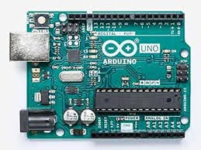

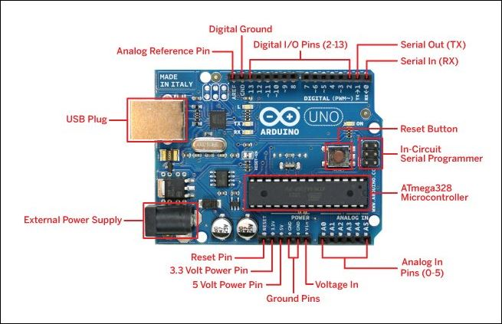

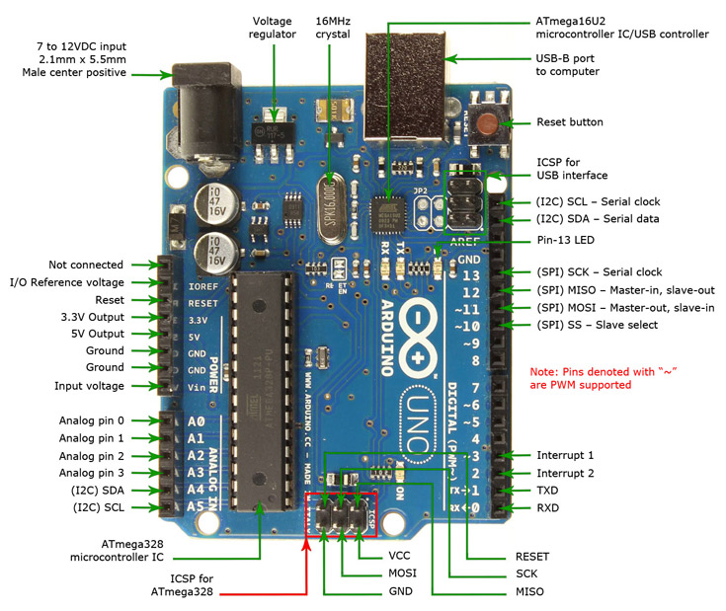

**Some Technical Specification of Arduino Uno is:**

1. Micro controller ATmega328P
2. Operating Voltage 5V
3. Input Voltage (recommended) 7-12V
4. Input Voltage (limits) 6-20V
5. Digital O Pins 14
6. Analog Input Pins 6
7. DC Current per O Pin 40 Ma
8. DC Current for 3.3V Pin 50 mA
9. Flash Memory 32 KB of which 0.5 KB used by boot loader
10. SRAM 2 KB
11. EEPROM 1 KB
12. Clock Speed 16 MHz

**Pin Description**

|  |  |  |
| --- | --- | --- |
| Pin Category | Pin Name | Details |
| Power | Vin, 3.3V, 5V, GND | Vin: Input voltage to Arduino when using an external power source.  5V: Regulated power supply used to power micro controller and other components on the board 3.3V: 3,3V supply generated by on-board voltage regulator. Maximum current draw is 50nA. GND: ground pins. |
| Reset | Reset | Resets the micro controller, |

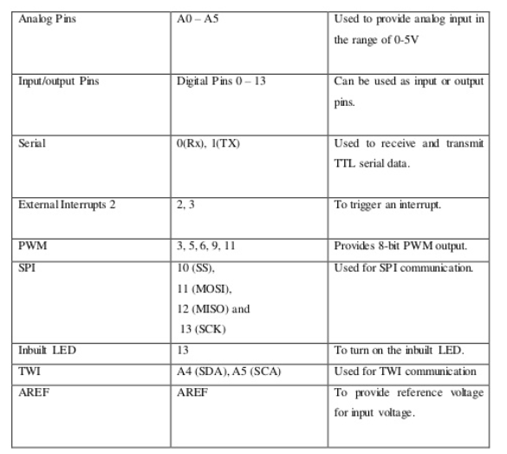

**3.1.3 Communication**

Arduino can be used to communicate with a computer, another Arduino board or other micro controllers. The ATmega328P micro controller provides UART TIL (5V) serial communication which can be done using digital pin 0 (Rx) and digital pin 1 (TX). An ATmega 16U2 on the board channels this serial communication over USB and appears as a virtual com port to software on the computer. The ATmega16U2 firmware uses the standard USB COM drivers, and no external driver is needed. However, on Windows, an inf fik is required. The Arduino software includes a serial monitor which allows simple textual data to be sent to and from the Arduino board. There are two RX and TX LEDS on the Arduino board which will flash when data is being transmitted via the USB-to-serial chip and USB connection to the computer (not for serial communication on pins 0 and 1). Software Serial library allows for serial communication on any of the Uno's digital pins. The ATmega328P also supports 12C (TWI) and SPI communication. The Arduino software includes a Wire library to simplify use of the 12C bus.

**Arduino Uno to ATmega328 Pin Mapping**

When ATmega328 chip is used in place of Arduino Um, or vice versa, the image below shows the pin mapping between the two.

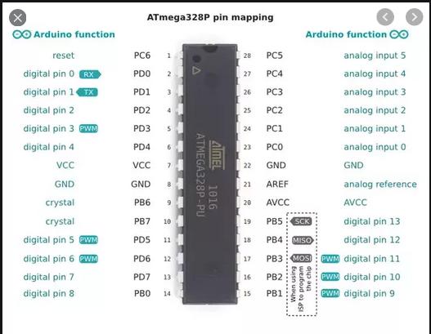

**3.2 ATmega328**

The ATmega328 s a singe-chip micro controller created by Atmel in the megaA VR family (inter Microchip Technology acquired Atmel in 2016). It has a modified Harvard architecture 8-bit RISC processor core.

**3.2.1 Specifications**

The Atmel 8-bit AVR RISC -based micro controller combines 32 kB ISP flash memory with read-write-write capabilities, 1 kB EEPROM, 2 kB SRAM, 23 general purpose I/O lines 32 general purpose working registers, three flexible timer/counters with compare modes, internal and external interrupts, serial programmable USART, a byte-oriented 2- wire serial interface, SPI serial port, 6-channel 10-bit A/D converter (8-chames in TQFP and QFNAMLF packages), programmable watchdog timer wäh internal oscillator, and five software s electable power saving modes. The device operates between 1.8-55 volts. The device achieves throughput approaching 1 MIPS per MHz

**3.2.2 Key parameters**

**Parameter Value**

CPU type 8-bt AVR

Performance 20 MIPS at 20MHz

Flash memory 32 kB

SRAM 2 kB

EEPROM 1 kB

Pin count 28 or 32 pin: PDIP-28, MLF-28, TQFP-32, and MLF- 32

Maximum operating frequency 20 MHz

Number of touch channel 16

Hardware QTouch Acquisition No

Maximum I/O pins 23

External interrupts 2

USB Interface No

USB Speed -

**3.2.3 Applications**

As of 2013 the ATmega328 is commonly used in many projects and autonomous systems where a simple, low-powered. low-cost micro-controller if needed [citation needed). Perhaps the most common implementation of this chip is on the popular Arduino development platform, namely the Arduino Uo and Arduino Nano model.

**3.3 HC-05 Bluetooth Module**

HC-05 module is an easy to use Bluetooth SPP (Serial Port Protocol module, designed for transparent wireless serial connection setup. Serial port Bluetooth module is fully qualified Bluetooth V2.0+EDR (Enhanced Data Rate) 3Mbps Modulation with complete 2.4GHZ radio transceiver and base band. It uses CSR Bluecore 04-Extemal single chip Bluetooth system with CMOS technology and with AFH (Adaptive Frequency Hopping Feature). It has the footprint as small as 12.7mm27mm. Hope it will simplify your overall design/development cyckHC-05. The HC-05 is a very cool module which can add two-way (fill-duplex) wireless functionality to your projects. You can use this module to communicate between two micro controllers Ike Arduino communicate with any device with Bluetooth or functionality like a Phone or Laptop. There are many android applications that are already available which makes this process a bit easier. The module communicates with the help of USART at 9600 baud rate hence it is easy to interface with any micro controller that supports USART. We can also configure the default values of the module by using the command mode. So if you looking for a Wireless module that could transfer data from your computer or mobile phone to micro controller or vice versa then this module might be the right choice for you. However do mt expect this module to transfer multimedia like photos or songs: you might have to look into the CSR8645 module for that.

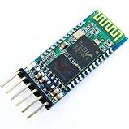

**3.3.1 Use the HC-05 Bluetooth module**

The HC-05 has two operating modes, one is the Data mode n which i can send and receive data from other Bluetooth devices and the other is the AT Command mode where the default device settings can be changed. We can operate the device in either of these two modes by using the key pin as explained in the pin description. It is very easy to pair the HC-05 module with micro controllers because it operates using the Serial Port Protocol (SPP). Simply power the module with +5V and connect the Rx pin of the module to the TX of MCU and TX pin of module to Rx of MCU as shown in the figure below

**3.3.2 HC-05 Bluetooth Module Circuit Connections**

During power up the key pin can be grounded to enter into Command mode, if left free it will by default enter into the data mode. As soon as the module is powered you should be able to discover the Bluetooth device as "HC-05" then connect with i using the default password 1234 and start communicating with t. The name password and other default parameters be changed can by entering into the application.

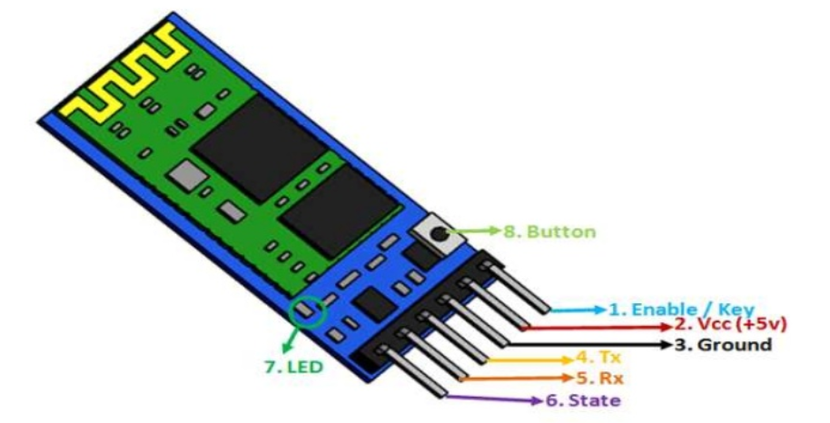

**3.3.3 Applications**

1. Wireless communication between two micro controllers
2. Communicate with Laptop, Desktops and mobile phones
3. Data Logging application
4. Consumer applications
5. Wireless Robots
6. Home Automation

**3.3.4 HC-05 Bluetooth Module Interfacing with Arduino UNO**

HC-05 is a Bluetooth device used for wireless communication with Bluetooth enabled devices (like smart phone). It communicates with micro controllers using serial communication (USART). Default settings of HC-05 Bluetooth module can be changed using certain AT commands. As HC-05 Bluetooth module has 3.3 V level for RX/TX and micro controller can detect 3.3 V level, so, there is no need to shift TX voltage level of HC-05 module. But we need to shit the transmit voltage level from micro controller RX of HC- 05 module.

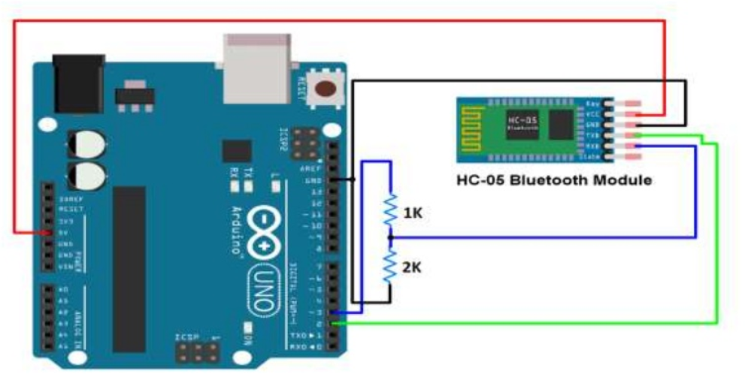

**3.4 4-Channel relay module**

This is a SV 4-channel relay interface board, and each channel needs a 15-20ma driver current. It can be used to control various appliances and equipment with hrge current. It is equipped with high-current relays that work under AC250V 10A or DC3OV 10A. It has a standard interface that can be controlled directly by micro controller 3.4.1 Principle From the picture below, you can see that when the signal port is at low level the signal light will light up and the opto coupler 7817e (it transforms electrical signal by light and can isolate input and output electrical signal) will conduct, and then the transistor will conduct, the relay coil will be electrified, and the normally open contact of the relay will be closed. When the signal port is at high level, the normally closed contact of the relay will be closed. So you can connect and disconnect the bad by controlling the level of the control signal port.

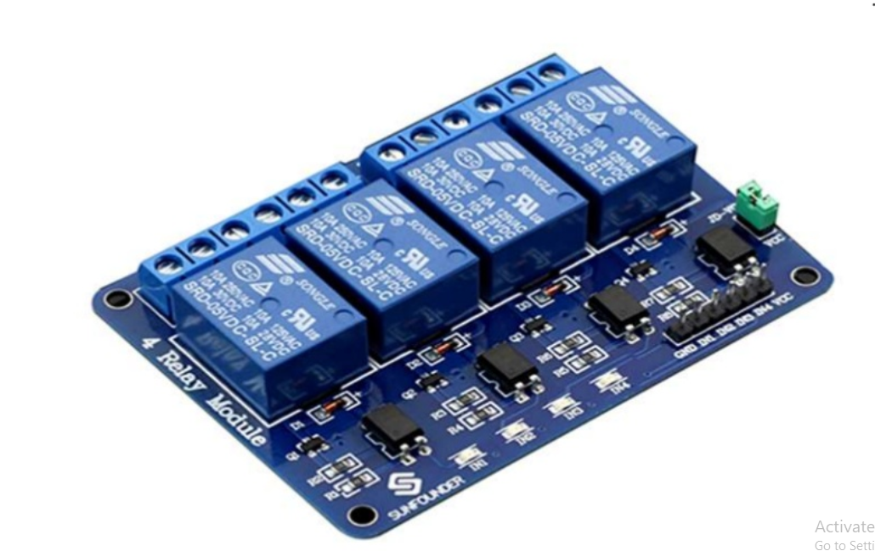

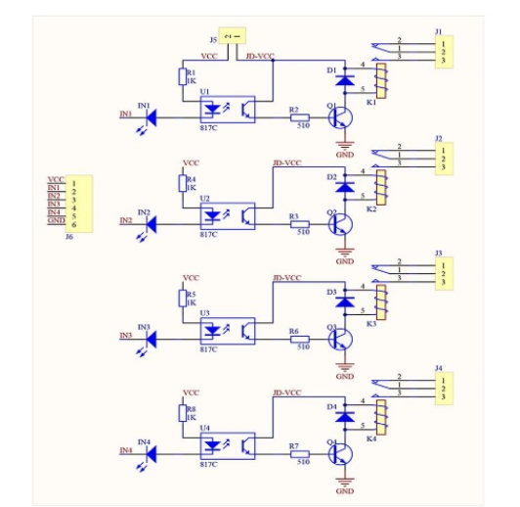

**3.4.2 Pin Description**

Input: VCC: Positive supply voltage GND: Ground INI-IN4: Relay control port Output : Connect à load, DC 30V/10A. AC 250V/10A 3.4.3 Features : 1. Size: 75mm (Length) • 55mm (Width) * 19.3mm (Height) 2. Weight: 61g 3. PCB Color: Blue 4. There are four fixed screw holes at each comer of the board, easy for install and fix. The diameter of the hole is 3.1mm 5. High quality Singe relay is used with single pol double throw, a common terminal, a normally open terminal, and a normally closed terminal 6. Optical coupling isolation good anti-interference. 7. Closed at low level with indicator on, released at high level with indicator off 8. VCC is system power source, and JD_VCC is relay power source. Ship 5V relay by default. Plug jumper cap to use 9. maximum output of the relay. DC 30V/10A, AC 250V/10A 24

**Chapter-5**

1. **Design And Implementation**

A blow cost and efficient smart home system is presented in our design. This system has two main modules: the hardware interface module and the software communication module. At the heart of this system is the Arduino Mega 626P micro controller which is of functioning as a micro web server and the interface for all the hardware Include All communication and controls in this system pass through the micro controller. Designing the Circuit

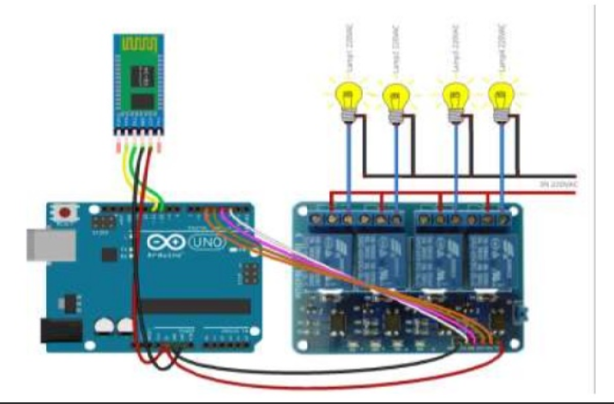

**CIRCUIT DAIGRAM**

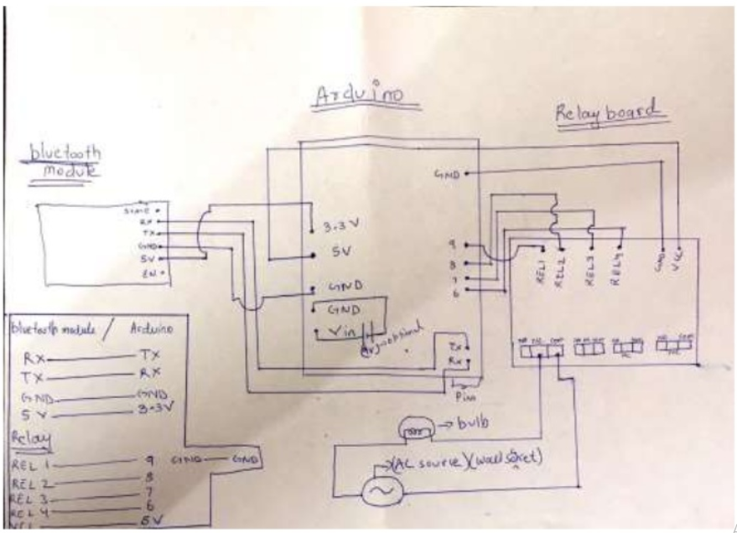

* 1. **Technical Specification for this project**

1. A smart phone or an Android mobile which should have the android app installed in it.
2. Bluetooth receiver module Our project will be connected to the smart phone using Bluetooth technology.
3. Controller or the main processing circuit- In this project, Arduino Uno is the main controlling / processing unit. Also, this project can be developed AVR ATmega32 and 8051 series like: 89s51, 89s52, 89v51RD2.
4. LCD Display - The Liquid Crystal Display is optional but shows important messages like device status once command is received from Bluetooth
5. Relays to control devices - We have used 12vol Single push single throw relays.

6) Output devices - For the dam purpose, we connected a DC devices to a relay (12 DC bulb). You can connect any AC/DC devices to the remaining 3 relays. Also, Device 6 is a Buzzer.

**Chapter-6**

1. **Pros of Home Automation**
2. **Security**

Tap your finger to tum on the lights when you get home so you worried about what's hiding in the shadows, or in your pathways. Or automate to tum on when you aren't home to look like you are to ward off potential robbers. Door bells are another automated home product that can increase your home security.

1. **Energy Efficiency**

Increase your home's energy efficiency by remotely powering off systems and appliances when they aren't in use. In addition to the standard home automation products that give you active control, some products actively monitor systems and am the homeowner with knowledge, insight and guidance to achieve greater control and energy efficiency,

1. **Savings**

Home automation literally pays off. When you are able to use home systems and appliances only when needed, the savings will be apparent in the first utility bill No more wasting money on lights left on when you aren't home, or spending money on gas to drive home because you forgot to lock the door. Monetary savings apparent, you'll also be saving time. No wasted trips home, no running through the house turning everything off no time spent worrying about what was or wasn't turned off

1. **Convenience**

Don't you hate having to rely on neighbors to watch you house when you're gone? With home automation convenient control of your home is at your fingertips. You don't have to trust someone eke with your most valued possessions.

**Cons of Home Automation**

1. **Cost of Intelligence**

Installing state-of-the-art features inside home results in a higher price tag for the property. The cost of an intelligence home that makes our lives convenient is high because some of the technology is relatively new. The cost of living expenses such as utilities. maintenance and repair of the technology can be expensive as well

1. **Technology Learning Curve**

Owning a smart home means having to learn how to use your home. Unlike traditional homes, smart home technology requires you to adapt to the innovations within your living area such as security systems, air units and a remote that control your entire house. For the technology-savvy family, the smart home will help achieve convenience faster. but for others, it will take reading manuals and leaning how-to before the benefits of convenience pay off.

1. **Video Surveillance**

Video surveillance can be a wonderful tool in heightening security and deterring crime. but when the technology falls into the wrong hands, issues of privacy can occur. Security sensors within the doors and walls of a smart hone use wireless technology to transfer signal to a central control unit notifies emergency officials of any foreign activity.

* 1. **Applications Of This Project**

1. Using this project, we can turn on or off appliances remotely i.e. using a phone or tablet.
2. The project can be further expanded to a smart home automation system by including some sensors like light sensors, temperature sensors, safety sensors etc. and automatically adjust different parameters like room lighting air conditioning (room temperature), door locks etc. and transmit the information to our phone
3. Additionally. we can connect to internet and control the home from remote location over internet and also monitor the safety. Future Development of the project.
4. Arduino based device control using Bluetooth on Smart-phone project can be enhanced to control the speed of the fan or volume of the buzzer etc.
5. Home automation and Device controlling can be done using Internet of Things - IOT technology.

6. We can replace Bluetooth by GSM modem so that we can achieve device controlling by sending SMS using GSM modem.

**Conclusion**

The home automation system has been experimentally proven to work satisfactorily by connecting sample appliances to it and the appliances were successfully controlled from a wireless mobile device. We learned many skill such as soldering, wiring the circuit and other tools that we use for this project and was able to work together as a team during this project, The Bluetooth client was successfully tested on a multitude of different mobile phones from different manufacturers, thus proving its portability and wide compatibility. Thus a low-cost home automation system was successfully designed, implemented and tested.